|  |  |
| --- | --- |
|  | Project Specification |
|  |  |
| 3/4/2013 | Auto Indexer |
|  | This phase of project allows auto indexing to be part of RF.com website. This allows automatic extraction and allocation from |

Contents

Use Cases 2

Auto Indexer 2

Indexer Process 2

UC-PKI-AI-2 - Indexer Process 2

QC Process 9

UC-PKI-AI-6 - QC Process 9

Actors 16

Requirements 17

Glossary 18

Open Issues 19

s

# Use Cases

## Auto Indexer

This phase of project allows auto indexing to be part of RF.com website. This allows automatic extraction and allocation from

## Indexer Process

### UC-PKI-AI-2 - Indexer Process

It allows Indexer to verify the extracted data.

|  |  |
| --- | --- |
| Preconditions Authenticated Indexer is logged in. | Success Guarantee PDF file is assigned to the Auditor |

#### Main Success Scenario

1. System opens pdf file in different window DGM-Indexer PDF Window.ndx
2. System populates all data fields in the data section in form DGM-Indexer Extract Screen.ndx
3. System displays the File no,File Name,Path,Traking no.
4. System displays User ID of Indexer in the field "Entered By" and it is not editable.
5. Indexer chooses the Rotate angle in the drop down.
6. Indexer clicks on rotate Button.
   1. System rotates pdf file based on the rotate angle.
7. Indexer enters the text in the text box of search.
8. Indexer clicks on search button.
   1. System searches the text in pdf file.
9. Indexer clicks on Zoom in Button.
   1. System increases the zoom size by 20%.
10. Indexer clicks on zoom out.
    1. System decreases the zoom size by 20%.
11. Indexer clicks on delete button.
    1. System pops up message for confirmation.
       1. Indexer clicks on "Yes"
          1. System closes pop up message
          2. System deletes the current page.
12. Indexer verifies/modify data entry form.
13. Indexer selects state from the drop down list.
14. Indexer selects prefix from the drop down list.
    1. System automatically populated Prefix field from the Sub TOI table.
15. Indexer selects the filling type in the drop down list.
16. Indexer verifies/modify data in the following fields:
    1. LOB
    2. SERFF tracking No.
    3. CO Filing No
    4. Preview Pages
    5. Sub TOI
    6. TOI
       1. System automatically populated TOI field from the Sub TOI table.
    7. Reviewer(s)
    8. Project No
    9. Pages
    10. Description
    11. Internal notes
17. System allows Auditor to edit data in the following fields from Company Details Section.
    1. DOI Number
    2. Company Number
    3. Company Name
    4. Prop.Rate Change
    5. App.Rate Change
    6. Program
    7. OverAll Indicated Chg
    8. Written Premium Chg
    9. No Of Policy Holder Affected
    10. Written Premium
18. Indexer clicks on Delete icon from company details.
    1. System pops up message for confirmation.
       1. Indexer clicks on "Yes"
          1. System closes pop up message
          2. System allows Indexer to delete the data.
19. Indexer verifies/modify status date.
    1. System validates the date as per requirement REQ-PK-AI-1.
20. Indexer selects the status from the drop down.
21. Indexer verifies/modify Filing date.
    1. System validates the date as per requirement REQ-PK-AI-1.
22. Indexer verifies/modify the NB EFF date.
    1. System validates the date as per requirement REQ-PK-AI-1.
    2. System validates the date as per requirement REQ-PK-AI-3.
23. Indexer verifies/modify the RB EFF date.
    1. System validates the date as per requirement REQ-PK-AI-1.
    2. System validates the date as per requirement REQ-PK-AI-4.
24. Indexer verifies/modify the Received Date.
    1. System validates the date as per requirement REQ-PK-AI-1.
25. Indexer clicks on Flag check box.
26. Indexer clicks on Push check box.
27. Indexer enters the text in the description field.
    1. System checks the spelling of the entered text and displays the error at the same time.
28. Indexer enters the text in the internal notes field.
    1. System checks the spelling of the entered text and displays the error at the same time.
29. Indexer clicks on save button.
    1. System checks Extracted Data from data base with Indexer screen data
    2. If Extracted Data matches Indexer screen data
    3. System allows Indexer to save current edits done.
    4. System pops up message Save successfully.
30. Indexer clicks on next button.
    1. System checks Extracted Data from data base with Indexer screen data
    2. If Extracted Data matches Indexer screen data
    3. System save the current filing data.
    4. System allocates file to auditor
    5. System opens the next pdf file.
31. Indexer clicks on Add More button.
    1. System pops up message "Do you want to add any more?"
    2. Indexer clicks on Yes.
    3. System adds one row for adding company details.
    4. Indexer can not change State,Prefix, Filing Type, LOB, Status, SERFF Tracking No, Description.
32. Indexer clicks on Duplicate file.
    1. System pops up confirmation message "Do you want to mark it as duplicate file?".
    2. Indexer clicks on "Yes"
       1. System mark File as duplicate file.
       2. System moves file to the Auditor and the screen is highlighted with red color.
    3. System moves to next file.
33. Indexer Enters RFC No. for RFC Pull process and clicks RFC Pull button
    1. Indexer screen gets filled with Filing Detail and Filing Company Detail from database
    2. Indexer clicks save button
       1. System overwrites the new filing data with existing filing data.
    3. Indexer clicks on Next button.
       1. System overwrites the new filing data with existing filing data ,set IsRFCPull flag to True and opens next file to be Indexed.

#### Extensions

8.1.a No text found in the pdf file by the System.

9.a System checks zoom in percentage.

1. zoom percentage>400 System disables the zoom in button.

2. use case continues with step 10.

10.a System checks zoom out percentage.

1. zoom percentage<200 System disable the zoom out button.

2. use case continues with step 11.

11.1.1.a Indexer clicks on "No"

1. System closes pop up

2. System does not delete the page

3. use case continue with step 12

17.2.a Auditor enter the Company Number.

1. System changes Company Name.

2. use case continues with step 17.3

17.3.a Auditor enter the Company Name.

1. System changes Company Number.

2. use case continues with step 17.4

17.4.a Auditor selects Filing Type which contains "Rate" in it.

1. System enables Prop.Rate Change,App.Rate Change fields.

2. Use case continues with step 17.6

18.1.1.a Indexer clicks on "No"

1. System closes pop up

2. System does not delete the page

3. use case continue with step 19

29.2.a System adds the unmatched data entry in the Agent Mistake table.

30.2.a System adds the unmatched data entry in the Agent Mistake table.

31.2.a Indexer clicks on "No"

1. System does not adds more data.

2. case continues with step 32.

32.2.a Indexer clicks on "No"

1. System close the confirmation message.

33.a Indexer clicks RFC Pull Button and left RFC Pull field blank.

1. System validates RFC Pull fields as a required field.

* 3/26/2012 Note that only the logged in Auditor will be allocated PDF file.
* 3/26/2012 The Maximum number of file allocated to Auditor will be 20, which can be edited in web.config file of website.
* 3/26/2012 Filing Type will be all possible combinations, like "Form/Rate" etc.



##### Activity Diagram

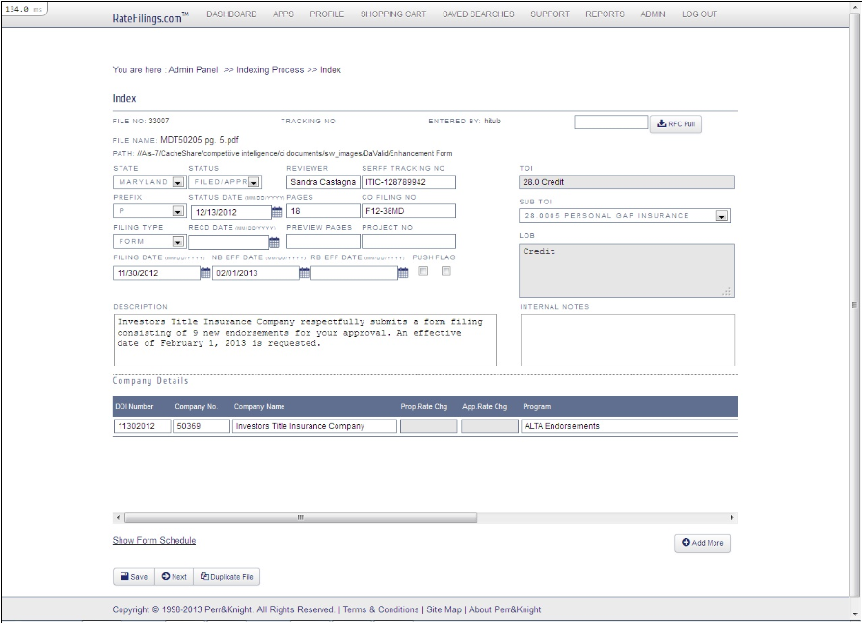

##### Indexer Extract Screen

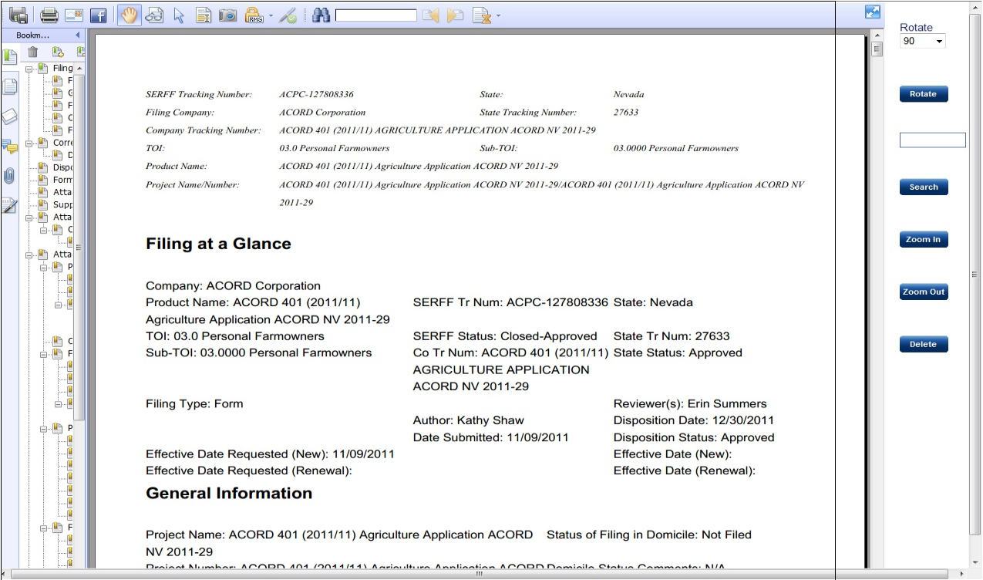

##### Indexer PDF Window

##### Activity Diagram

## QC Process

### UC-PKI-AI-6 - QC Process

It allows Auditor to review the data.

|  |  |
| --- | --- |
| Preconditions Auditor is logged on and System allocates file for processing. | Success Guarantee System submit current file for RFC generation.  System upload generated file in RF.com |

#### Main Success Scenario

1. System opens pdf file in separate window DGM-QC PDF Window.ndx
2. System populates all data fields in the data section in form DGM-Qc Extract Screen.ndx
3. System displays the File no,File Name,Path,Traking no.
4. System displays User ID of Indexer in the field "Entered By" and it is not editable.
5. System displays User ID of Auditor in the field "PK-Auditor" and it is not editable.
6. Auditor chooses the rotate angle in the drop down.
7. Auditor clicks on rotate Button.
   1. System rotates pdf file based on the rotate angle.
8. Auditor verifies/modify the text in the text box of search.
9. Auditor clicks on search button.
   1. System searches the text in pdf file.
10. Auditor clicks on Zoom in Button.
    1. System increases the zoom size by 20%.
11. Auditor clicks on zoom out.
    1. System decreases the zoom size by 20%.
12. Auditor clicks on delete button.
    1. System pops up message for confirmation.
       1. Auditor clicks on "Yes"
          1. System closes pop up message
          2. System deletes the current page.
13. Auditor verifies/modify data entry form.
14. Auditor selects state from the drop down list.
15. Auditor selects prefix from the drop down list.
    1. System automatically populated Prefix field from the Sub TOI table.
16. Auditor selects the filling type in the drop down list.
17. Auditor verifies/modify data in the following fields:
    1. LOB
    2. SERFF tracking No.
    3. CO Filing No
    4. Preview Pages
    5. Sub TOI
    6. TOI
       1. System automatically populated TOI field from the Sub TOI table.
    7. Reviewer(s)
    8. Project No
    9. Pages
    10. Description
    11. Internal notes
18. System allows Auditor to edit data in the following fields from Company Details Section.
    1. DOI Number
    2. Company Number
    3. Company Name
    4. Prop.Rate Change
    5. App.Rate Change
    6. Program
    7. OverAll Indicated Chg
    8. Written Premium Chg
    9. No Of Policy Holder Affected
    10. Written Premium
19. Auditor clicks on Delete icon from company details.
    1. System pops up message for confirmation.
       1. Auditor clicks on "Yes"
          1. System closes pop up message
          2. System allows Auditor to delete the data.
20. Auditor verifies/modify status date.
    1. System validates the date as per requirement REQ-PK-AI-1.
21. Auditor selects the status from the drop down.
22. Auditor verifies/modify Filing date.
    1. System validates the date as per requirement REQ-PK-AI-1.
23. Auditor verifies/modify the NB EFF date.
    1. System validates the date as per requirement REQ-PK-AI-1.
    2. System validates the date as per requirement REQ-PK-AI-3.
24. Auditor verifies/modify the RB EFF date.
    1. System validates the date as per requirement REQ-PK-AI-1.
    2. System validates the date as per requirement REQ-PK-AI-4.
25. Auditor verifies/modify the Received Date.
    1. System validates the date as per requirement REQ-PK-AI-1.
26. Auditor clicks on Flag check box.
27. Auditor clicks on Push check box.
28. Auditor enters the text in the description fields.
    1. System checks the spelling of the entered text and displays the error at the same time.
29. Auditor enters the text in the internal notes field.
    1. System checks the spelling of the entered text and displays the error at the same time.
30. Auditor clicks on save button.
    1. System checks Indexed data from database and Auditor screen data
    2. if Indexed data from database matches with Auditor screen data
    3. System saves current edits done.
    4. System displays message Save successfully.
31. Auditor clicks on next button.
    1. System checks Indexed data from database and Auditor screen data.
    2. if Indexed data from database matches with Auditor screen data
    3. System saves the current data.
    4. System checks whether Auditor has reviewed all filings in current PDF.
       1. If Auditor has reviewed all filings in current pdf.
          1. System checks if IsRFCPull flag is false
             1. System generates RFC file for current PDF.
             2. System upload generated file in RF.com
             3. System update PdfFilestsid to 'RFC Pending' of the current filing.
             4. System opens the next pdf file.
32. Auditor clicks on Add More button.
    1. System displays message "Do you want to add any more?"
    2. Auditor clicks on Yes.
    3. System adds one row for adding company details.
    4. Auditor can not change State,Prefix, Filing Type, LOB, Status, SERFF Tracking No, Description.
33. Auditor clicks on Duplicate file.
    1. System pops up confirmation message "Do you want to mark it as duplicate file?".
    2. Auditor clicks on "Yes"
       1. System mark File as duplicate file.
       2. System skip the current file.
    3. System moves to next file.

#### Extensions

*.a * Auditor does any changes.

1. System saves old data.

1.1. System captures new data.

1.a Files are not available.

1. System displays messge"No files available".

9.a No text found in the pdf file by the System.

10.a System checks zoom in percentage.

1. if zoom percentage>400 System disables the zoom in button.

2. use case continues with step 11.

11.a System checks zoom out percentage.

1. if zoom percentage<200 System disable the zoom out button.

2. use case continues with step 12.

12.1.1.a Auditor clicks on "No"

1. System closes pops up.

2. System does not delete the page.

3. use case continue with step 13.

18.2.a Auditor enter the Company Number.

1. System changes Company Name.

2. use case continues with step 18.3

18.3.a Auditor enter the Company Name.

1. System changes Company Number.

2. use case continues with step 18.4

18.4.a Auditor selects Filing Type which contains "Rate" in it.

1. System enables Prop.Rate Change,App.Rate Change fields.

2. Use case continues with step 18.6

19.1.1.a Auditor clicks on "No"

1. System closes pop up

2. System does not delete the data

3. use case continue with step 20

23.2.a Auditor verifies/modify NB EFF date.

1. Year greater than 5 years of filing date.

2. System displays error message "The date should be within 5 years of filing date".

3. case continues with the step 24.

24.2.a Auditor verifies/modify RB EFF date.

1. Year greater than 5 years of filing date.

2. System displays error message "The date should be within 5 years of filing date".

3. case continues with the step 25.

30.2.a System inserts unmatched data entry in to Agent mistake table.

31.2.a System inserts unmatched data entry in to Agent mistake table.

31.3.a If the file is duplicate file System skips the current file and open the next allocated file.

1. case continues with step 2.

31.4.1.a Auditor has not reviewed all filing in current PDF.

1. System gives error message "Review all PDF filing".

2. use case continues with step 2.

31.4.1.1.a System checks if IsRFCPull flag is true

1. System updates the filing detail and filing company detail in the database.

2. System opens next file.

32.2.a Auditor clicks on "No"

1. System does not add more data.

2. case continues with step 33.

33.a Auditor clicks on Index button.

1. System mark file as Not a Duplicate file

2. System changes text color to the black in the Auditor screen

3. Auditor can verify the data and save the changes.

33.2.a Auditor clicks on "No"

1. System does not marks file as duplicate file.

* 3/21/2012 If the file is duplicate the project screen highlighted with red color
* 3/21/2012 If the file opened is duplicate the Button is renamed as Index



##### Activity Diagram

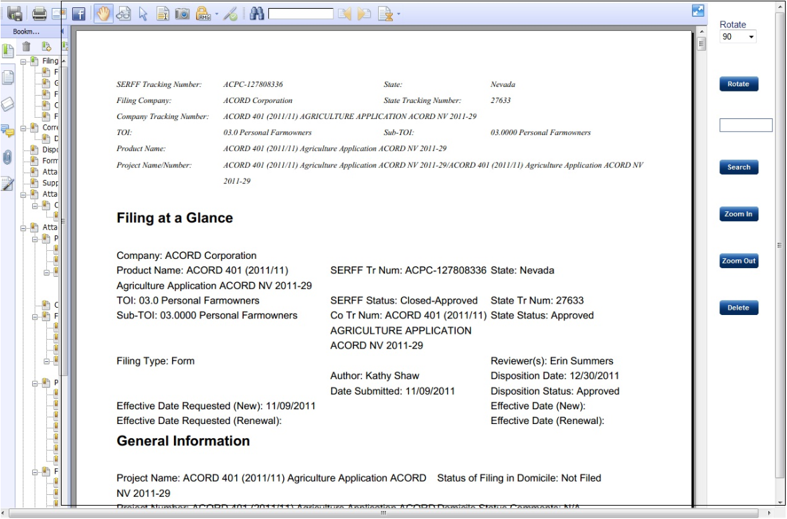

##### QC PDF Window

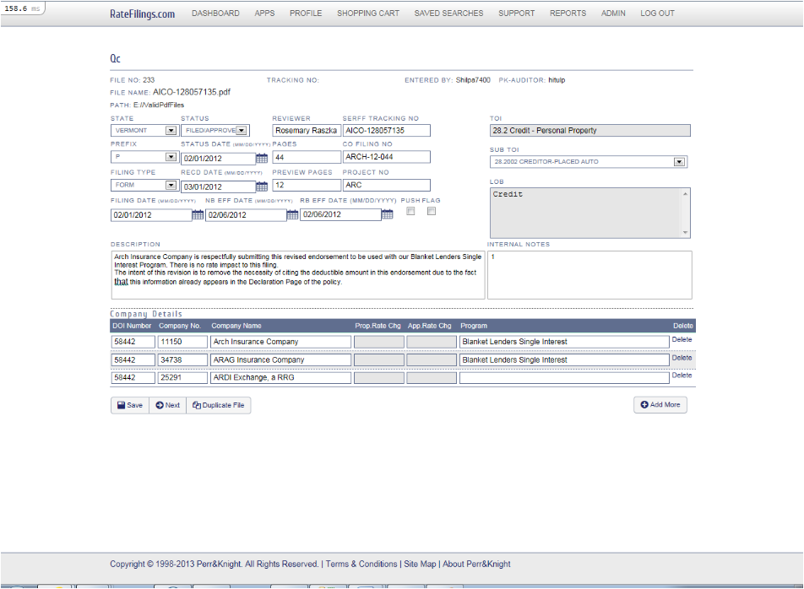

##### Qc Extract Screen

# Actors



|  |  |  |
| --- | --- | --- |
| Name | Description | Participates in |
| Admin (A-PKI-AI-3) |  |  |
| Auditor (A-PKI-AI-5) |  | UC-PKI-AI-6 QC Process |
| Indexer (A-PKI-AI-4) |  | UC-PKI-AI-2 Indexer Process |
| System (A-PKI-AI-1) |  | UC-PKI-AI-2 Indexer Process  UC-PKI-AI-6 QC Process  UC-PKI-AI-8 Extract Process  UC-PKI-AI-9 Allocation Process |
| User (A-PKI-AI-2) |  |  |

# Requirements

|  |  |  |
| --- | --- | --- |
| Requirement | Description | Type |
| REQ-PKI-AI-2  REQ-PK-AI-1 | The date should be in the form of MM/DD/YYYY. | Non-functional |
| REQ-PKI-AI-4  REQ-PK-AI-12 | Date should be in the form of MM/DD/YYYY | Non-functional |
| REQ-PKI-AI-5  REQ-PK-AI-13 | The date should be in the form of MM/DD/YYYY.  To date is required when from date is filled. | Non-functional |
| REQ-PKI-AI-6  REQ-PK-AI-14 | The date should be in the form of MM/DD/YYYY  From date is required When To date is filled. | Non-functional |
| REQ-PKI-AI-6  REQ-PK-AI-3 | The year of NB EFF date should be within 5 years from the filing date. | Non-functional |
| REQ-PKI-AI-7  REQ-PK-AI-4 | The year of RB EFF date should be within 5 years from the filing date. | Non-functional |
| REQ-PKI-AI-7  REQ-PK-AI-2 | The Date should be current date.  The Date should be in the form of MM/DD/YYYY. | Non-functional |
| REQ-PKI-AI-8  REQ-PK-AI-6 | System maps NB EFF date with Effective Date Requested(New). | Non-functional |
| REQ-PKI-AI-9  REQ-PK-AI-7 | System maps NB EFF Date with Disposition Date. | Non-functional |
| REQ-PKI-AI-10  REQ-PK-AI-8 | System maps NB EFF Date with Date Submitted. | Non-functional |
| REQ-PKI-AI-11  REQ-PK-AI-9 | System maps RB EFF date with Effective Date Requested(Renewal). | Non-functional |
| REQ-PKI-AI-12  REQ-PK-AI-10 | System maps RB EFF Date with Date Submitted. | Non-functional |
| REQ-PKI-AI-13  REQ-PK-AI-11 | System maps RB EFF Date with Disposition Date. | Non-functional |

# Glossary

# Open Issues